**Додаток Ж**

**Результат виконання PostgreSQL запитів**

*select h_name,h_type,h_price,ci_name*

*from hotels*

*Left join city on city.ci_id_city = hotels.city*

*left join accommodation_type on hotels.accommodation_type = accommodation_type.a_id_accommodation_type*

*where h_price between 200 and 450;*

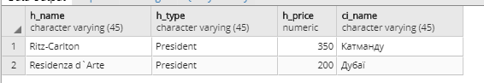

*select c_id_client,c_surname,c_name,f_name,f_city_of_departure,f_date_time_of_departure*

*from tours*

*join sales on tours.ts_id_tours = sales.tours*

*join flights on flights.f_id_flights = tours.flights*

*join client on client.c_id_client = sales.client*

*where c_id_client = (select f_id_flights from flights*

*where f_name = 'Airline' and f_date_time_of_departure = '2018-07-24');*



*select ts_id_tours,t_type_of_tour,f_name,f_city_of_departure,f_date_time_of_departure,f_city_arrives,*

*case*

*when ts_price between 50 and 250 then 'low class'*

*when ts_price between 250 and 500 then 'middle class'*

*when ts_price between 500 and 1100 then 'high class'*

*when ts_price > 500 then 'vip class'*

*end*

*as "Категорія"*

**Продовження додатку Ж**

*from tours*

*Right Join type_of_tour on type_of_tour.t_id_type_of_tour = tours.type_of_tour*

*Right Join flights on flights.f_id_flights = tours.flights;*

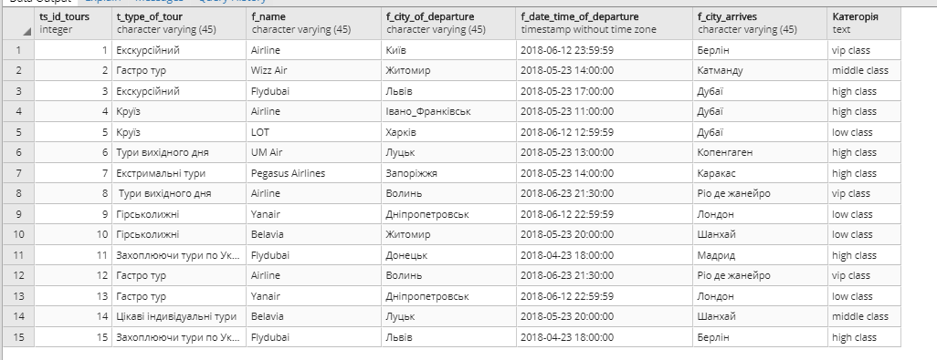

*select p_id_program,p_type,p_route,p_transport,p_price_in_dollars,tp_date,tp_time,*

*IF p_route is NULL or p_route = 'немає'*

*THEN*

*'Дія в готелі';*

*ELSE*

*'за межами готелю';*

*END IF;*

*AS Статус"*

*from program*

*inner join tour_program on tour_program.program = program.p_id_program ;*

*select f_id_flights,f_name,f_city_of_departure,f_date_time_of_departure,f_date_time_arrives,f_city_arrives*

*from tours*

*join sales on tours.ts_id_tours = sales.tours*

*join flights on flights.f_id_flights = tours.flights*

*join client on client.c_id_client = sales.client*

*where f_id_flights = (select c_id_client from client*

*where c_surname = 'Freik' and c_name = 'Vlad');*

**Продовження додатку Ж**

*select t_type_of_tour,ts_price,ts_star_date,ts_end_date,tf_type_of_food,*

*case*

*when ts_end_date - ts_star_date <= 7 then 'Короткотривалий'*

*when ts_end_date - ts_star_date < 8 and ts_end_date - ts_star_date > 6 then 'Тижневий'*

*when ts_end_date - ts_star_date >= 8 then 'Довготривалий'*

*end*

*as "Категорія"*

*from tours*

*Left Join type_of_tour on type_of_tour.t_id_type_of_tour = tours.type_of_tour*

*Left Join type_of_food on type_of_food.tf_id_type_of_food = tours.type_of_food*

*order by length(tf_type_of_food);*

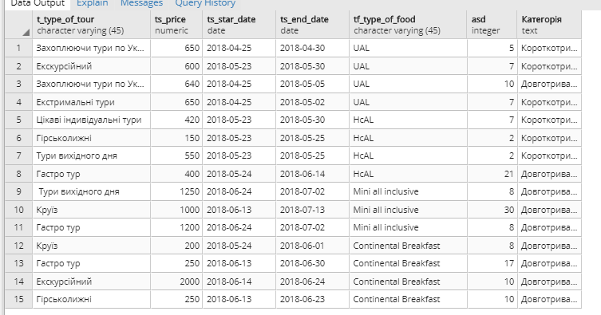

*(select ct_id_country,ct_name,h_name,h_type,h_number_of_stars*

*from country*

*join city on city.country = country.ct_id_country*

*join hotels on hotels.city = city.ci_id_city*

*where ct_id_country = (select h_id_hotels from hotels*

**Продовження додатку Ж**

*where h_type = 'asd' and h_number_of_stars = 4))*

*UNION*

*(select ct_id_country,ct_name,h_name,h_type,h_number_of_stars*

*from country*

*join city on city.country = country.ct_id_country*

*join hotels on hotels.city = city.ci_id_city*

*where ct_id_country = (select h_id_hotels from hotels*

*where h_type = 'asdad' and h_number_of_stars = 5));*

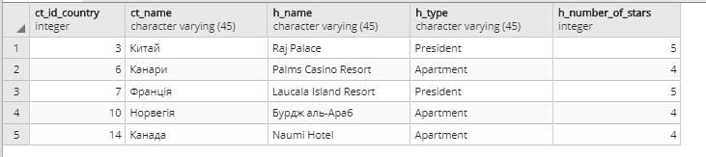

*select p_id_program,p_type,p_route,p_transport,tp_date,tp_time*

*from program,tour_program*

*where program.p_id_program = tour_program.program*

*and tp_date = '2000-12-12' and tp_time is not null ;*



*select ts_id_tours,ts_star_date,ts_end_date,ts_price,tf_type_of_food,*

*h_name,a_accommodation_type*

*from tours*

*right join hotels on hotels.h_id_hotels = tours.hotels*

*right join type_of_food on type_of_food.tf_id_type_of_food = tours.type_of_food*

*right join accommodation_type on accommodation_type.a_id_accommodation_type = hotels.accommodation_type*

*where ts_id_tours = ANY(select p_id_program from program*

*where p_route is null);*

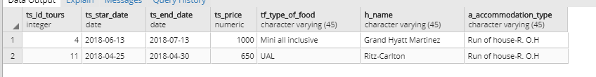

**Закінчення додатку Ж**

*select c_surname, c_name, c_middle_name,s_date,tours,ts_id_tours,ts_star_date,*

*ts_end_date,ts_price*

*from client*

*right join sales on client.c_id_client = sales.Client*

*right join tours on tours.ts_id_tours = sales.Tours*

*where c_id_client = ALL(select s_id_sales from sales*

*where s_count = 14);*